**Personal Finance PowerBI Dashboard**

A project that utilizes Microsoft PowerBI to analyze personal HNI-Financial Data and visualize expenses through an interactive dashboard.

*"Data analysis is not just about presenting data, but to build a story and create a meaningful narrative from the raw data. At the end of the day, that's what analytics is all about - not about writing code, not about crunching numbers, not about memorizing formula syntax - it's about deriving meaning and context from the data and, more importantly, using it to make real change."* *- Chris Dutton, Maven Analytics*

**Problem Description**

As with any responsible financial management, I’ve been tracking all transactions using Excel. While this gives a basic overview, it lacks depth for high-value portfolios. To enable detailed insights and smarter decision-making, we’re transforming this static data into a dynamic Power BI dashboard tailored for HNI finances.

**Project Goals**

Here are the questions I would like the PowerBI dashboards to answer:

* Monthly and quarterly spending trends
* Category-wise expenditure analysis
* Detailed expense tracking with comments
* Location-based spending breakdown
* Purchase distribution by value range
* Weekly and average cost analysis (daily, weekly, monthly)
* Food vs. restaurant cost comparison
* Behavioral trends during health-related events
* Weekday vs. weekend spending patterns

In order to answer these questions, I invested time in planning the PowerBI measures I would need to create and also planned a rough outline of the dashboard visuals I wanted.

**Data Analysis Summary**

Here are the dashboards that I created. If you would like to actually play around with these dashboards see the end of this readme for instructions:

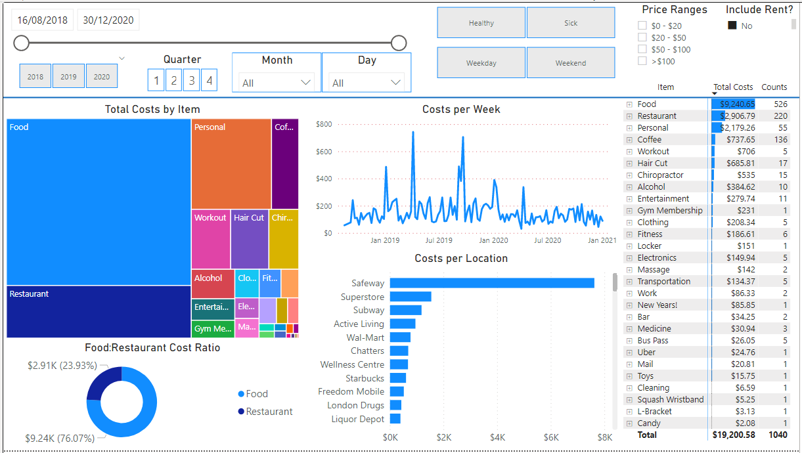

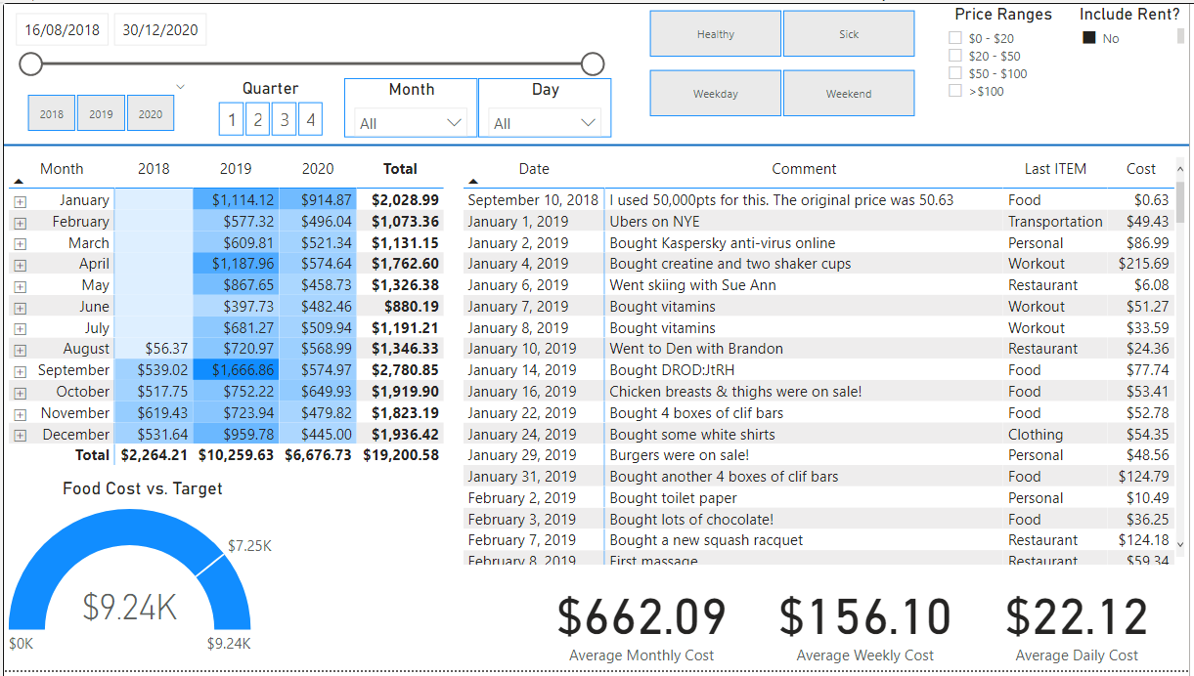

**Hardware and Software Used**

* Python (v3.8)
* Python Libraries: openpyxl, os
* Windows 10 Machine
* Microsoft PowerBI Desktop (v2.93)
* Microsoft Excel

**Overview of Microsoft Power BI**

Microsoft Power BI is a data analytics tool used to provide business intelligence capabilities, including loading, modelling, and visualizing data sets. Its initial release was over 10 years ago in July 2011, and since then the Microsoft team has continued to add greater functionality and improve ease-of-use on a monthly basis.

The program itself can be used both on a local machine (via Power BI "Desktop") and also on the cloud (via Power BI "Services"). It can be used in a similar fashion as how one may use Excel, but also provides the greater ability to more easily create interactive visualizations called 'dashboards'.

**Explanation of Project Files**

Here is a brief description of each file/folder found in this GitHub repository.

**Finance Data/20xx**

The Finance Data/20xx folder contains monthly Excel workbooks, capturing detailed financial data over a 3-year period—from January 2023 to December 2025.

**change_excel_sheets.py**

This Python script takes in an Excel file with multiple sheets and renames all sheets to 'Sheet1'. (*Apparantly this was necessary for importing the Excel data into PowerBI?*)

**Finance_Data.xlsx**

This is a copy of the original Excel file that I was using to keep track of my spending.

**Personal_Finance_Dashboard.pbix**

This is the main Power BI file containing the finance dashboards.

**Data Collection Methodology**

I collected this data by keeping all purchase receipts and inputting the data manually into Excel. The information I kept track of was: Date, Item Category, Price, Location, Comment.

In order to import this data into PowerBI, it was quite the process. Since the data was contained in *multiple Excel sheets in the same Excel workbook*, I first had to separate the sheets into their own Excel workbook - this turned out to be the easiest avenue to importing the data.

**Data Cleaning**

There was quite a bit of data cleaning to do. I had to do some basic editing of the 'Item' category column, in order to have consistent categories. For example, I had 'hair cut', 'Hair cut', 'Hair-Cut' as separate categories, and so had to standardize this into simply a 'Hair Cut' category.

There was a lot of work needed to be done with dates. Some dates were of a 'Text' type, some were a 'General' type, and still others were the 'Date' type. These had to be standardized.

Finally, only a few rows contained null entries, so I simply chose to remove these rows from the overall dataset; This would not drastically affect the variance of the overall data.

**Measure Creation & Visualizations**

In order to help answer the questions listed above, I started by making three other tables: (i) Calendar Lookup, (i) Item Lookup, (iii) Location Lookup.

The calendar lookup contains each range of dates from the data. From this I created various other useful calculated columns including month name/number, month-and-year, quarter, and end of week/month.

The item lookup table contained a single column of each distinct Item category. While working through the project, I realized that every month had a rental payment listed. It didn't make sense to me to have this consistently in each month, so I created a filter that can be used to manually include or exclude rental payments. To accomplish this, I needed a second column in the Item Lookup table to represent the 'Rent' item as a Boolean.

The location table contains a single column of each distinct location of purchase.

Once these lookup tables were ready, I followed my planned layout above and created each visual one at a time. As I created these, I also created the associated measure I would need to portray the data. Some of the measures I made were:

* total cost
* price ranges
* average cost per day, week, year
* Boolean to address my sick days

The main visuals I used were 'slicers'. I created calendar slicers for overall date, year, quarter, month, and day of week. With these ones has a lot of options as to what granularity they wish to visualize their data with respect to dates. I also have two slicers for weekday/weekend and healthy/sick selections. There is also a slicer that acts as a dropdown to select various purchase price ranges.

**Conclusion**

Using PowerBI I was able to visualize my purchases data in an interactive way. This allowed me to drill deeper into my spending behaviour and with this information I can now be more conscientious of what I choose to spend my money on.

**How You Can View My Power BI Dashboards**

For those interested in actually playing around with the dashboard, here are some detailed steps to help you do so:

**1. Download PowerBI**

Go to this site: <https://powerbi.microsoft.com/en-us/desktop/> and click the "Download Free" button in the center of the screen *(this may change in the future!)*. There may be a prompt that asks you to download from the Microsoft Store instead, in which case simply click the button that opens the Microsoft Store and install the application from there.

*Note: You****DO NOT****have to sign-in to use this 'Desktop' version, although if you choose to then you'll need to use a work/school email adddress.*

**2. Configure Some Settings**

Open Power BI Desktop and simply close the large dialog window that starts. Then, go: File -> Options and settings -> Options. On the left side you'll see two general categories of options: GLOBAL and CURRENT FILE.

Under the GLOBAL options, go to 'Preview features' and de-select all options.

Under the CURRENT FILE options, go to 'Data load' and de-select the two options: (i) Update or delete relationships when refreshing data, and (ii) Autodetect new relationships after data is loaded.

Finally, again under the CURRENT FILE options, go to 'Regional Settings' and make the appropriate selection for your region.

**3. Download My Project Files**

Now that everything is set up, you simply have to download all my project files as they are into a folder on your machine, open the Power BI file (the one with .pbix extension) and have fun!

**Future Steps**

For future improvement, we can consider the following ideas:

* Attempt to create more visually appealing dashboards (perhaps you can find a template to use?).
* Perhaps there is a way to generalize this dashboard so anyone can use it? (Launch via Docker container?)
  + Would need to ask users to standardize their Excel sheets a certain way?
* Think of new informative metrics that may be useful.
* Create new or modify existing dashboards for ease-of-use on mobile/tablet devices. (Can be done in Power BI Desktop)

**Acknowledgements**

* Creators of Microsoft PowerBI - It's a pretty amazing tool!
* All the kind and patient cashiers who took the time to print out a receipt for me.
* Viewers of my GitHub page...Thanks for visiting!